Creation EC2 Key Pair
- Creation an “EC2 Key Pair” to connect to the EMR cluster via any SSH client
a. Open the Amazon console and type “EC2” in the search bar of the dashboard, select it.
b. In the navigation pane, under Network & Security, choose Key Pairs
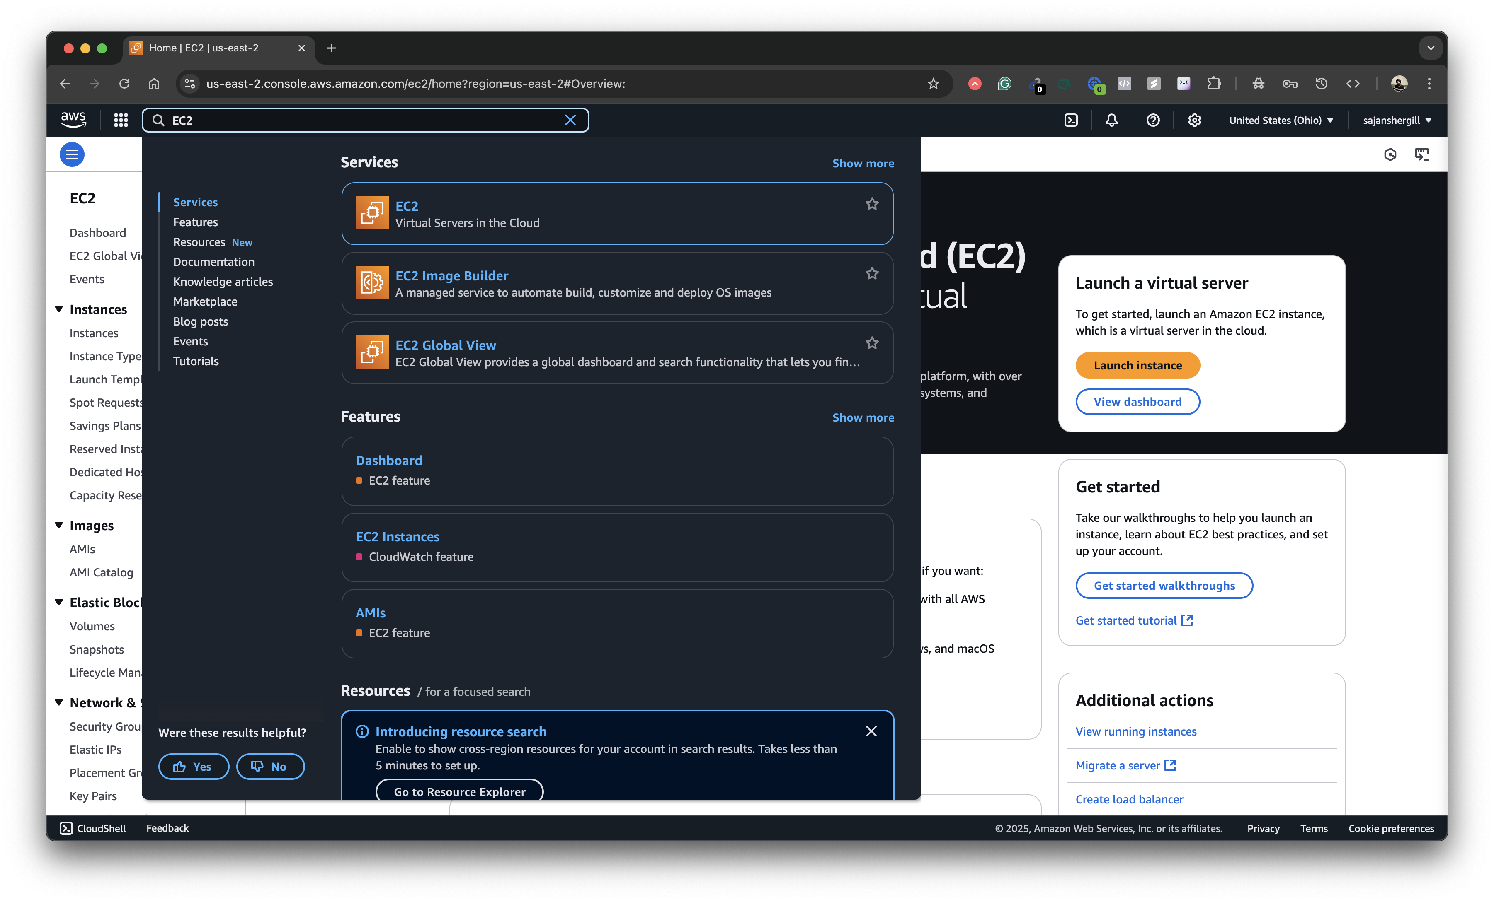
c. Choose Create key pair.
For Name, enter a descriptive name for the key pair. Amazon EC2 associates the public key with the name that you specify as the key name.
“pem” configuration is more suitable for Mac/Linux
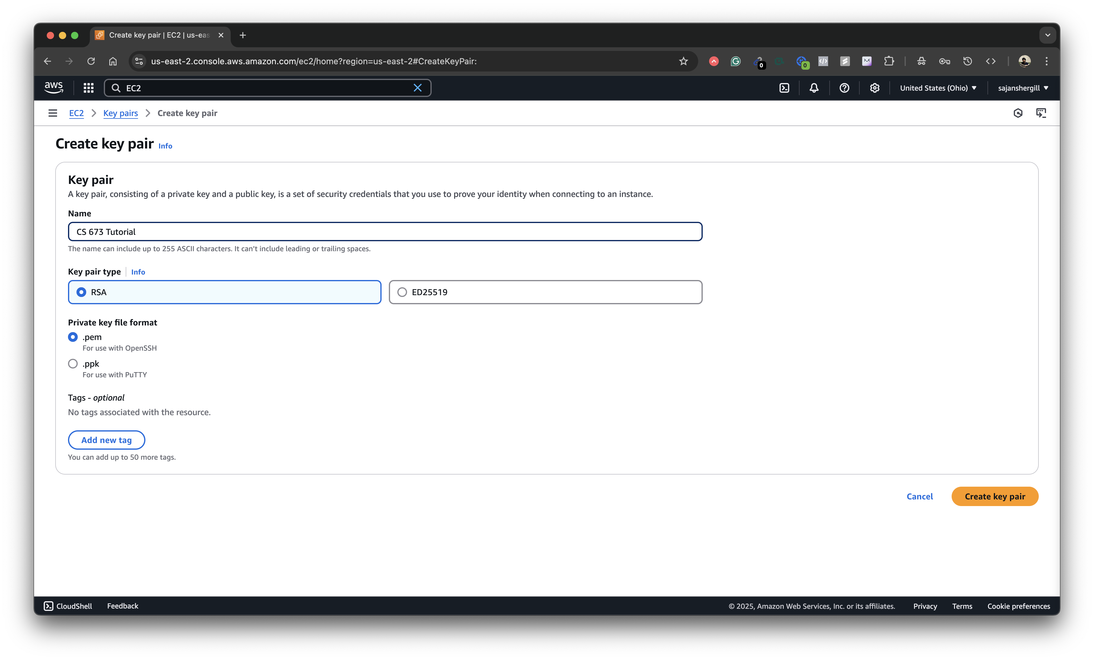
d. For Key pair type, choose either RSA
e. The private key file is automatically downloaded by your browser. The base
file name is the name that you specified as the name of your key pair, and the file
name extension is determined by the file format that you chose. Save the private key file in a safe place.

Creation the EMR cluster
- Creation the EMR cluster. First of all, please change your region to “Ohio”
- Open the Amazon console and type “EMR” in the search bar of the dashboard, select it.
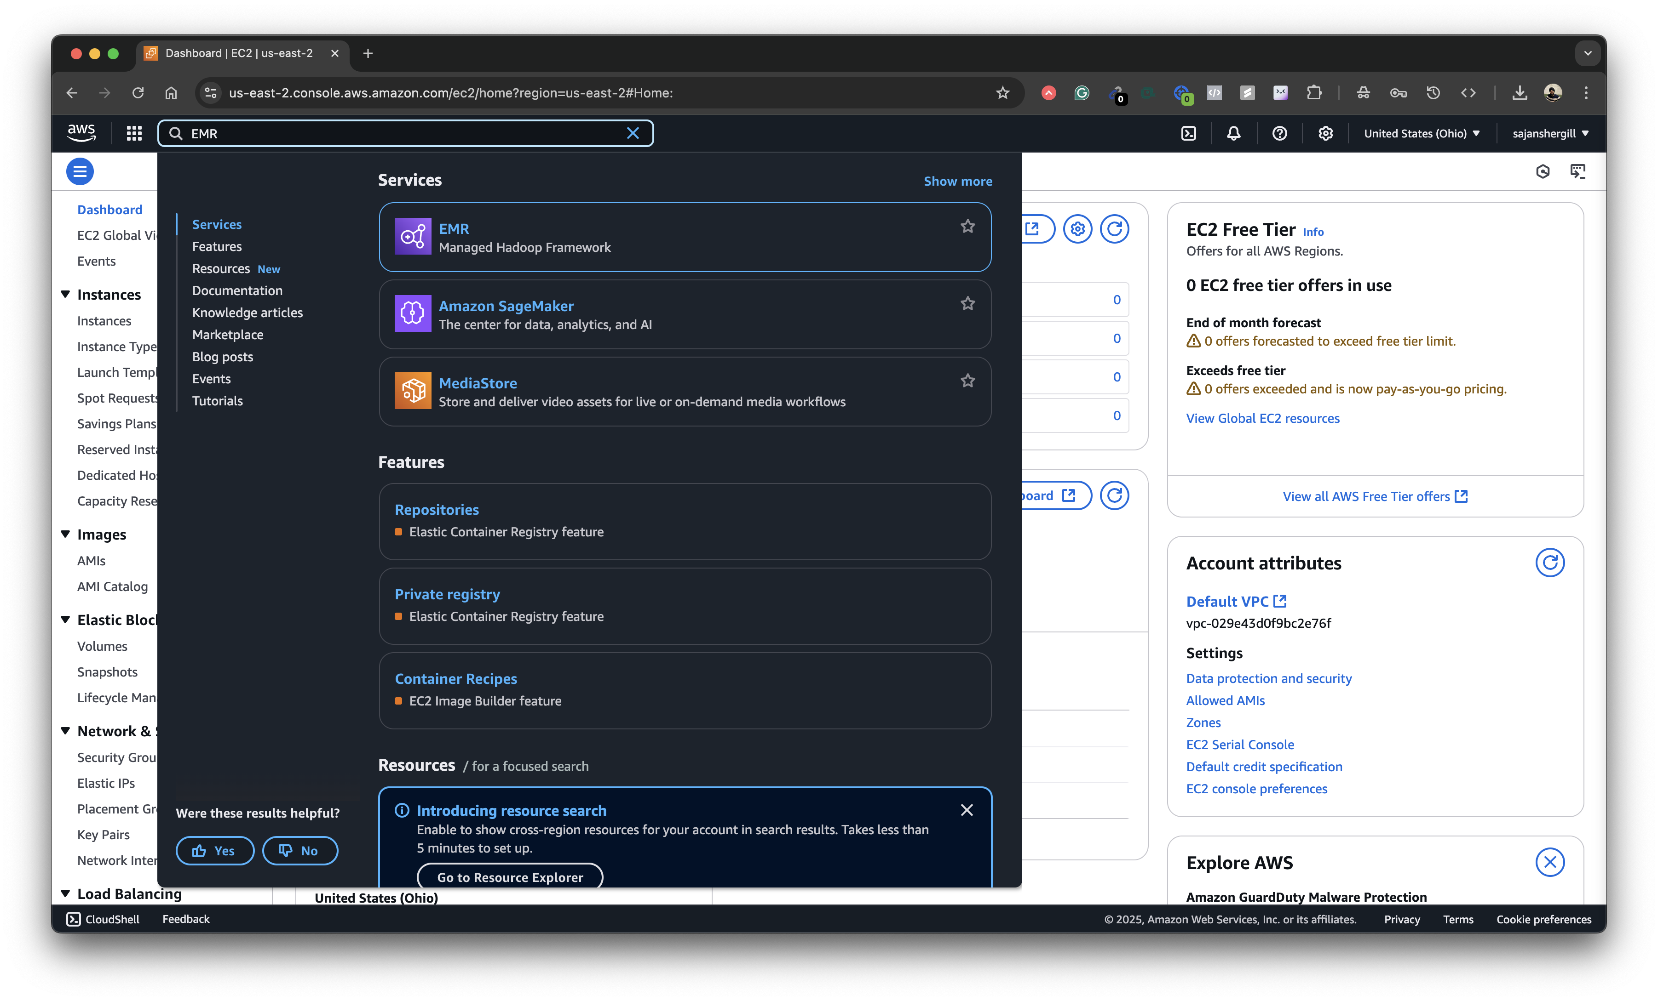
- Choose Create cluster.
Provide a Name to the cluster and select any Release of EMR (Ex: emr-7.0.0) Keep the instance type as m5.xlarge and you can change the “Number of Instances” as per your requirement. It will be sufficient 1 instance for us.

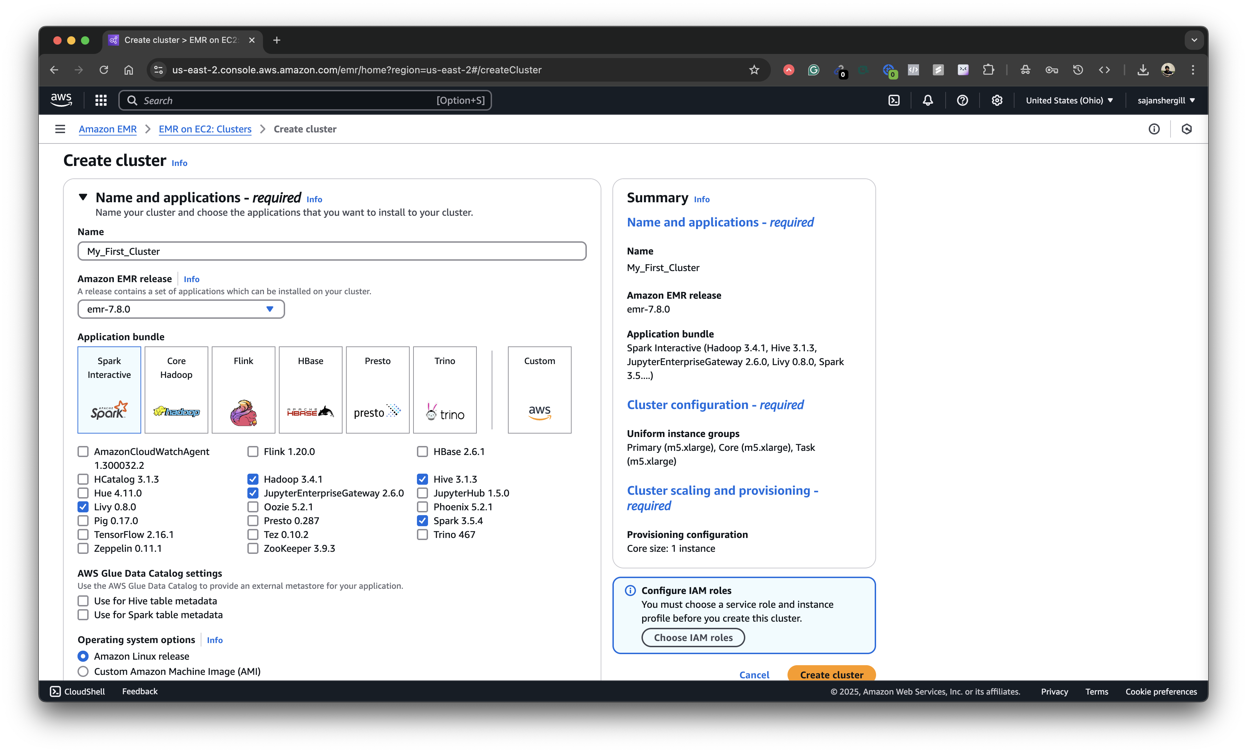

Keep the instance type as m5.xlarge and you can change the “Number of Instances” as per your requirement. It will be sufficient 1 instance for us.
Keep remained other settings that were installed by default.

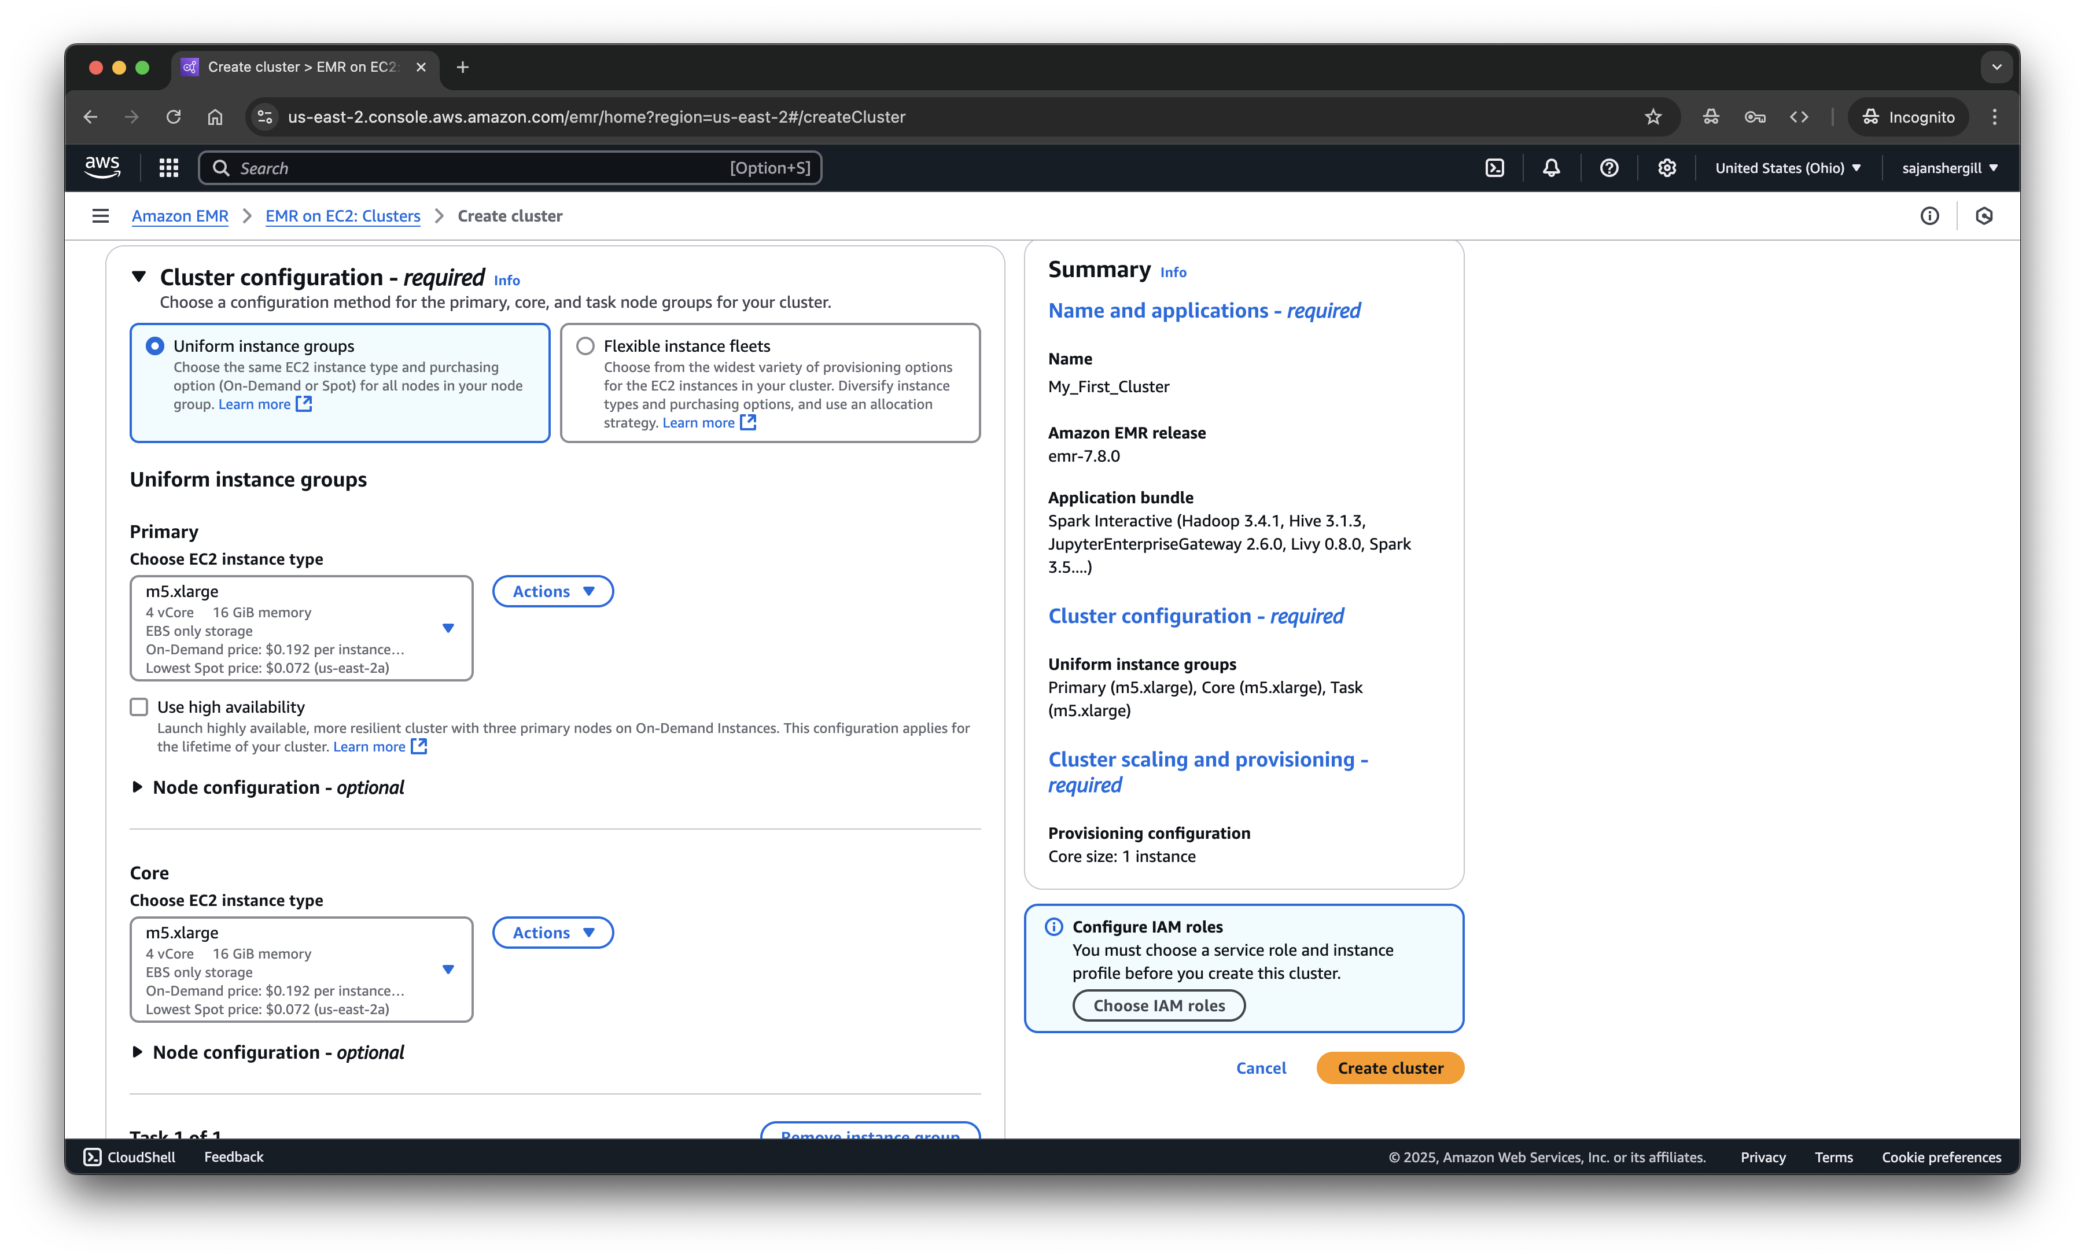
Within “EC2 key pair” field; select the key pair which you created in Step 1.
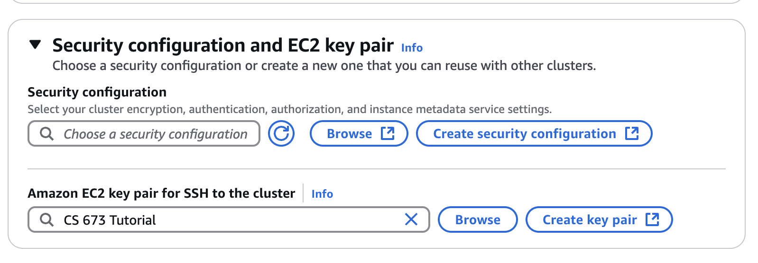
Select Service role - “EMR_DefaultRole”
Select Instance profile - “DemoRoleForEC2”
If you do not have “Dafault and Demo Roles”, please click on “Create a service role” and on “Create an instance profile” by keeping all default configurations.
After clicking on Create Cluster, it will take around 10- 15 minutes for the cluster to go in running state. In the meantime, follow step 3

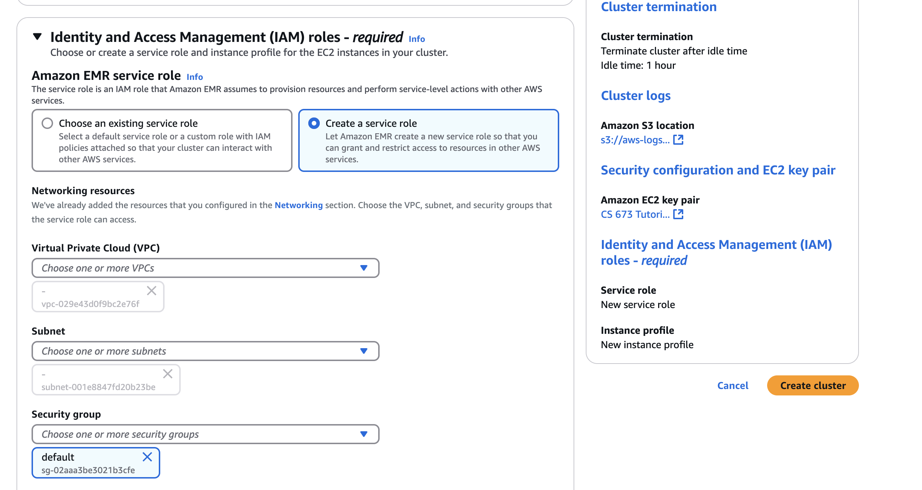
After clicking on Create Cluster, it will take around 10- 15 minutes for the cluster to go in running state. In the meantime, follow step 3
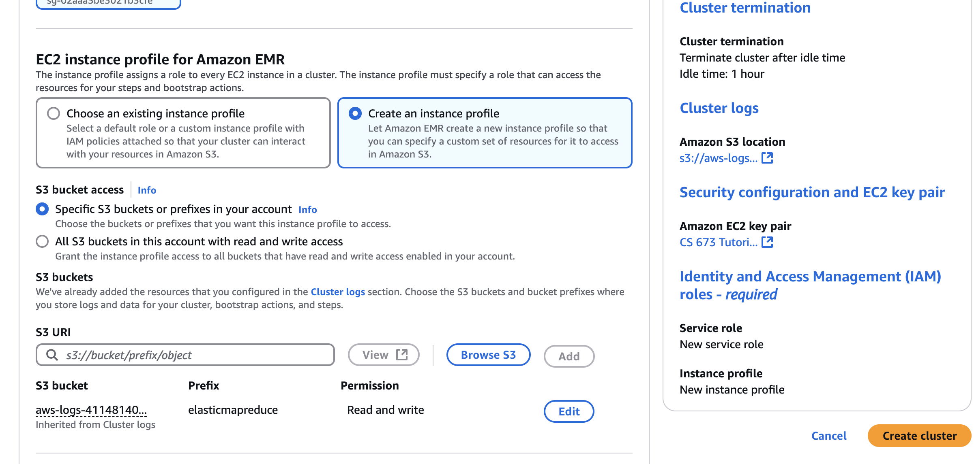

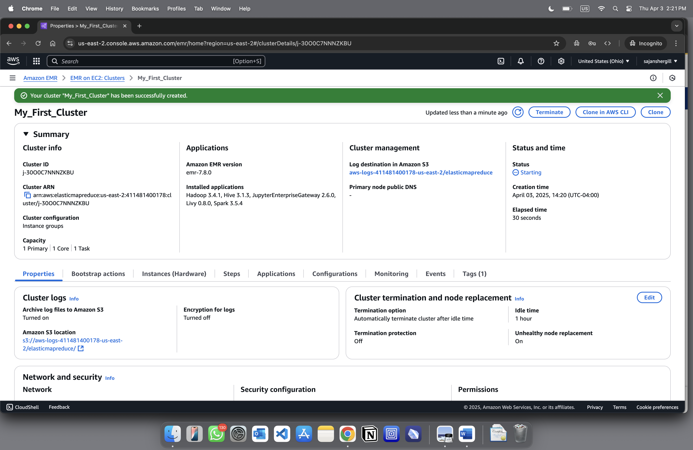

c. Now we need to add an inbound rule to the security group of Master Node which would allow all inbound connections on Port 22.
Go to EMR and click on “Clusters”
Click on the view details of the cluster which you have created.
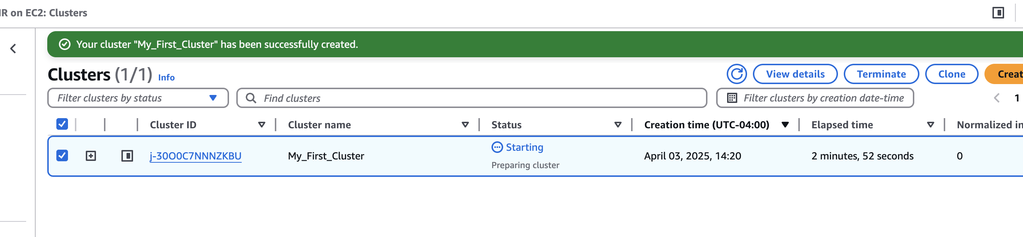

Scroll down and check the details within “Network and security”
Click on the “Security group id” for Primary node, it will lead you to ElasticMapReduce
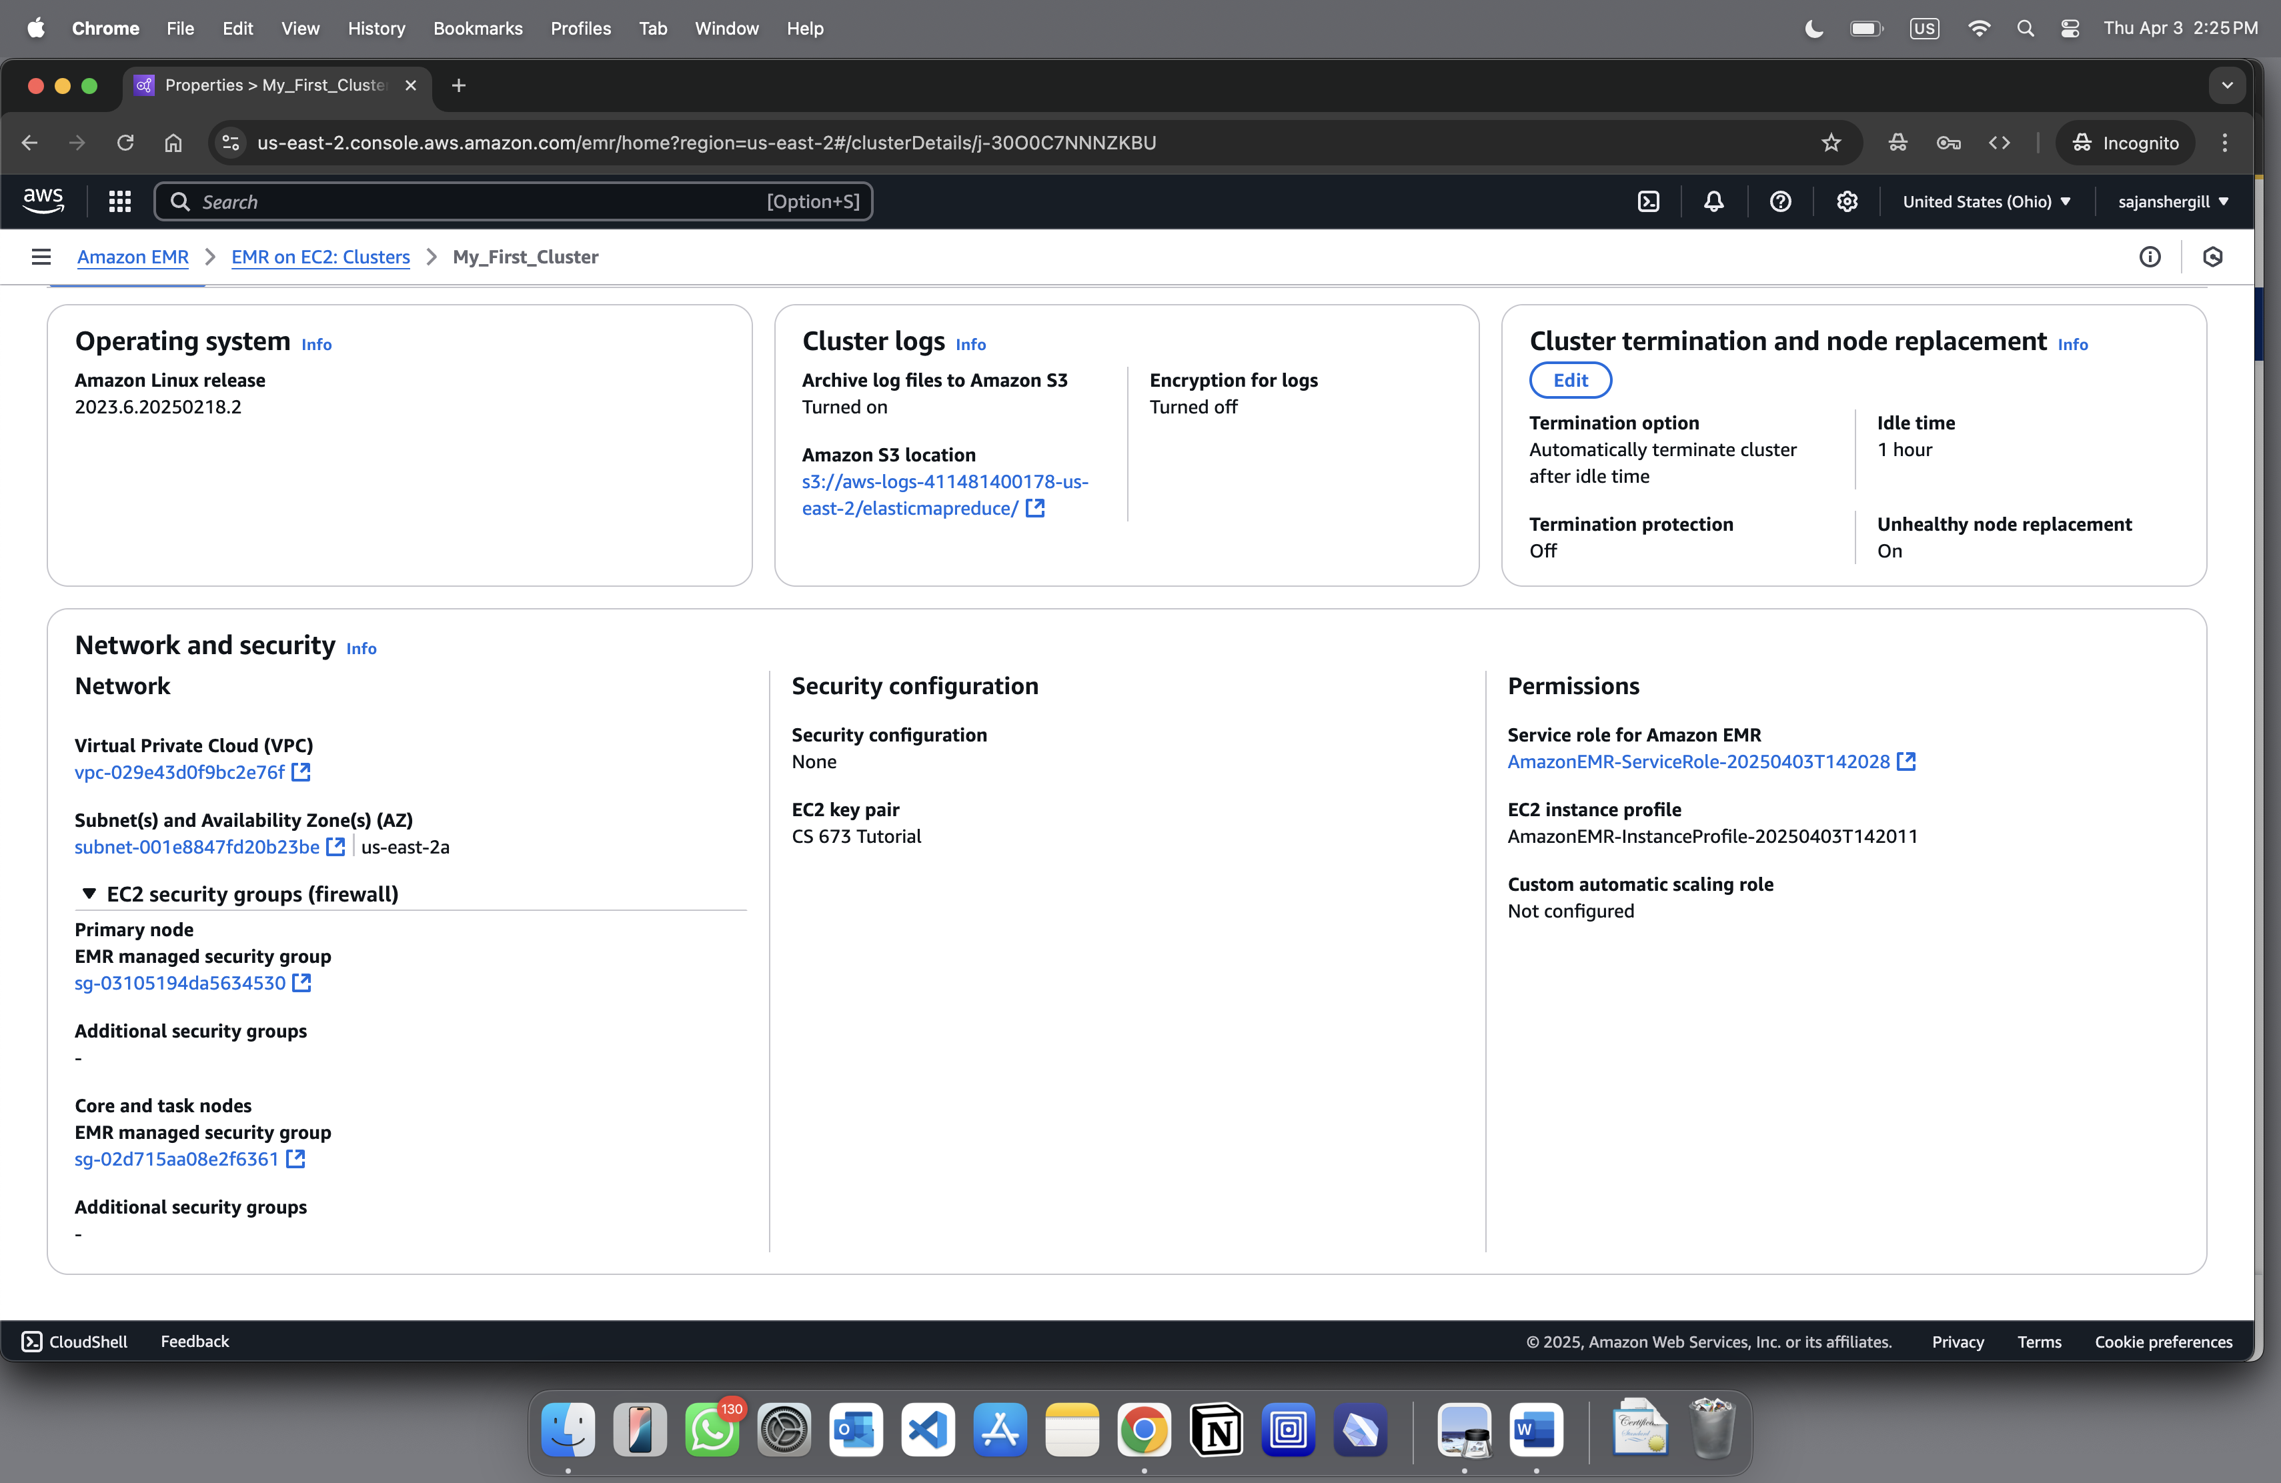

Scroll Down and click on “Edit inbound rules”
-> Scroll down and click on “Add rule”
-> Select Type as “SSH” and Source as “Anywhere-IPv4” as shown below:
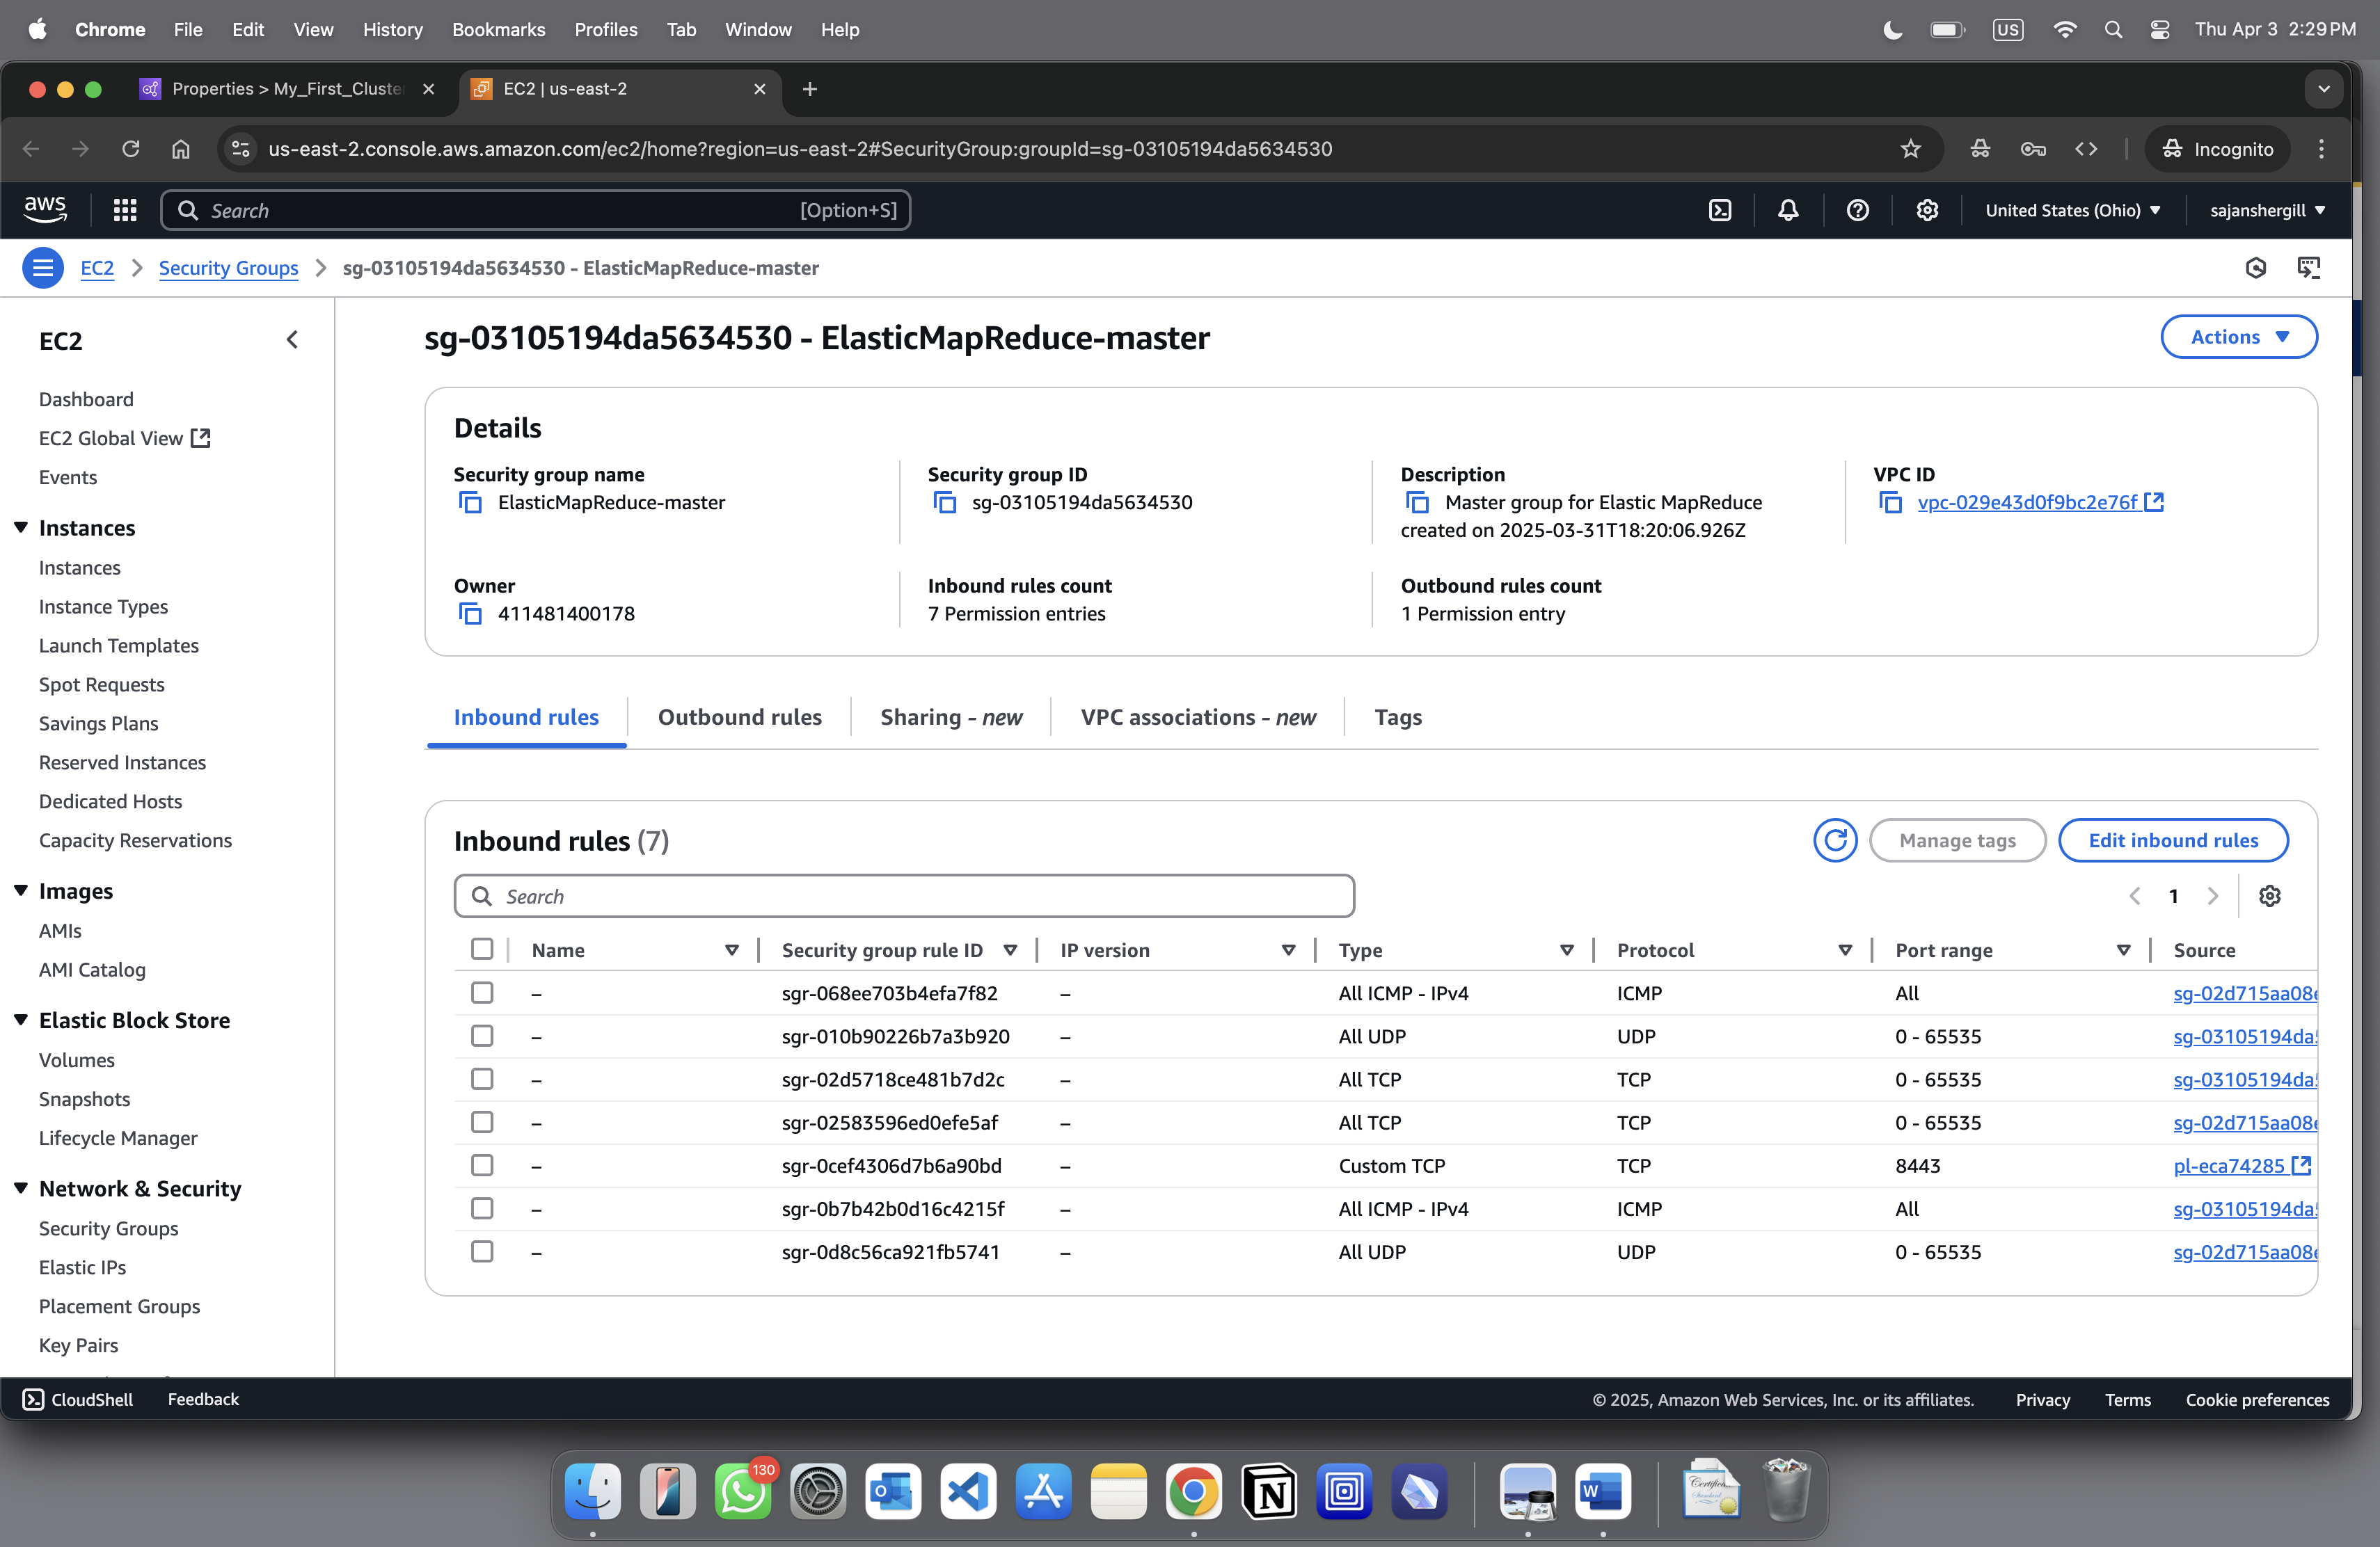
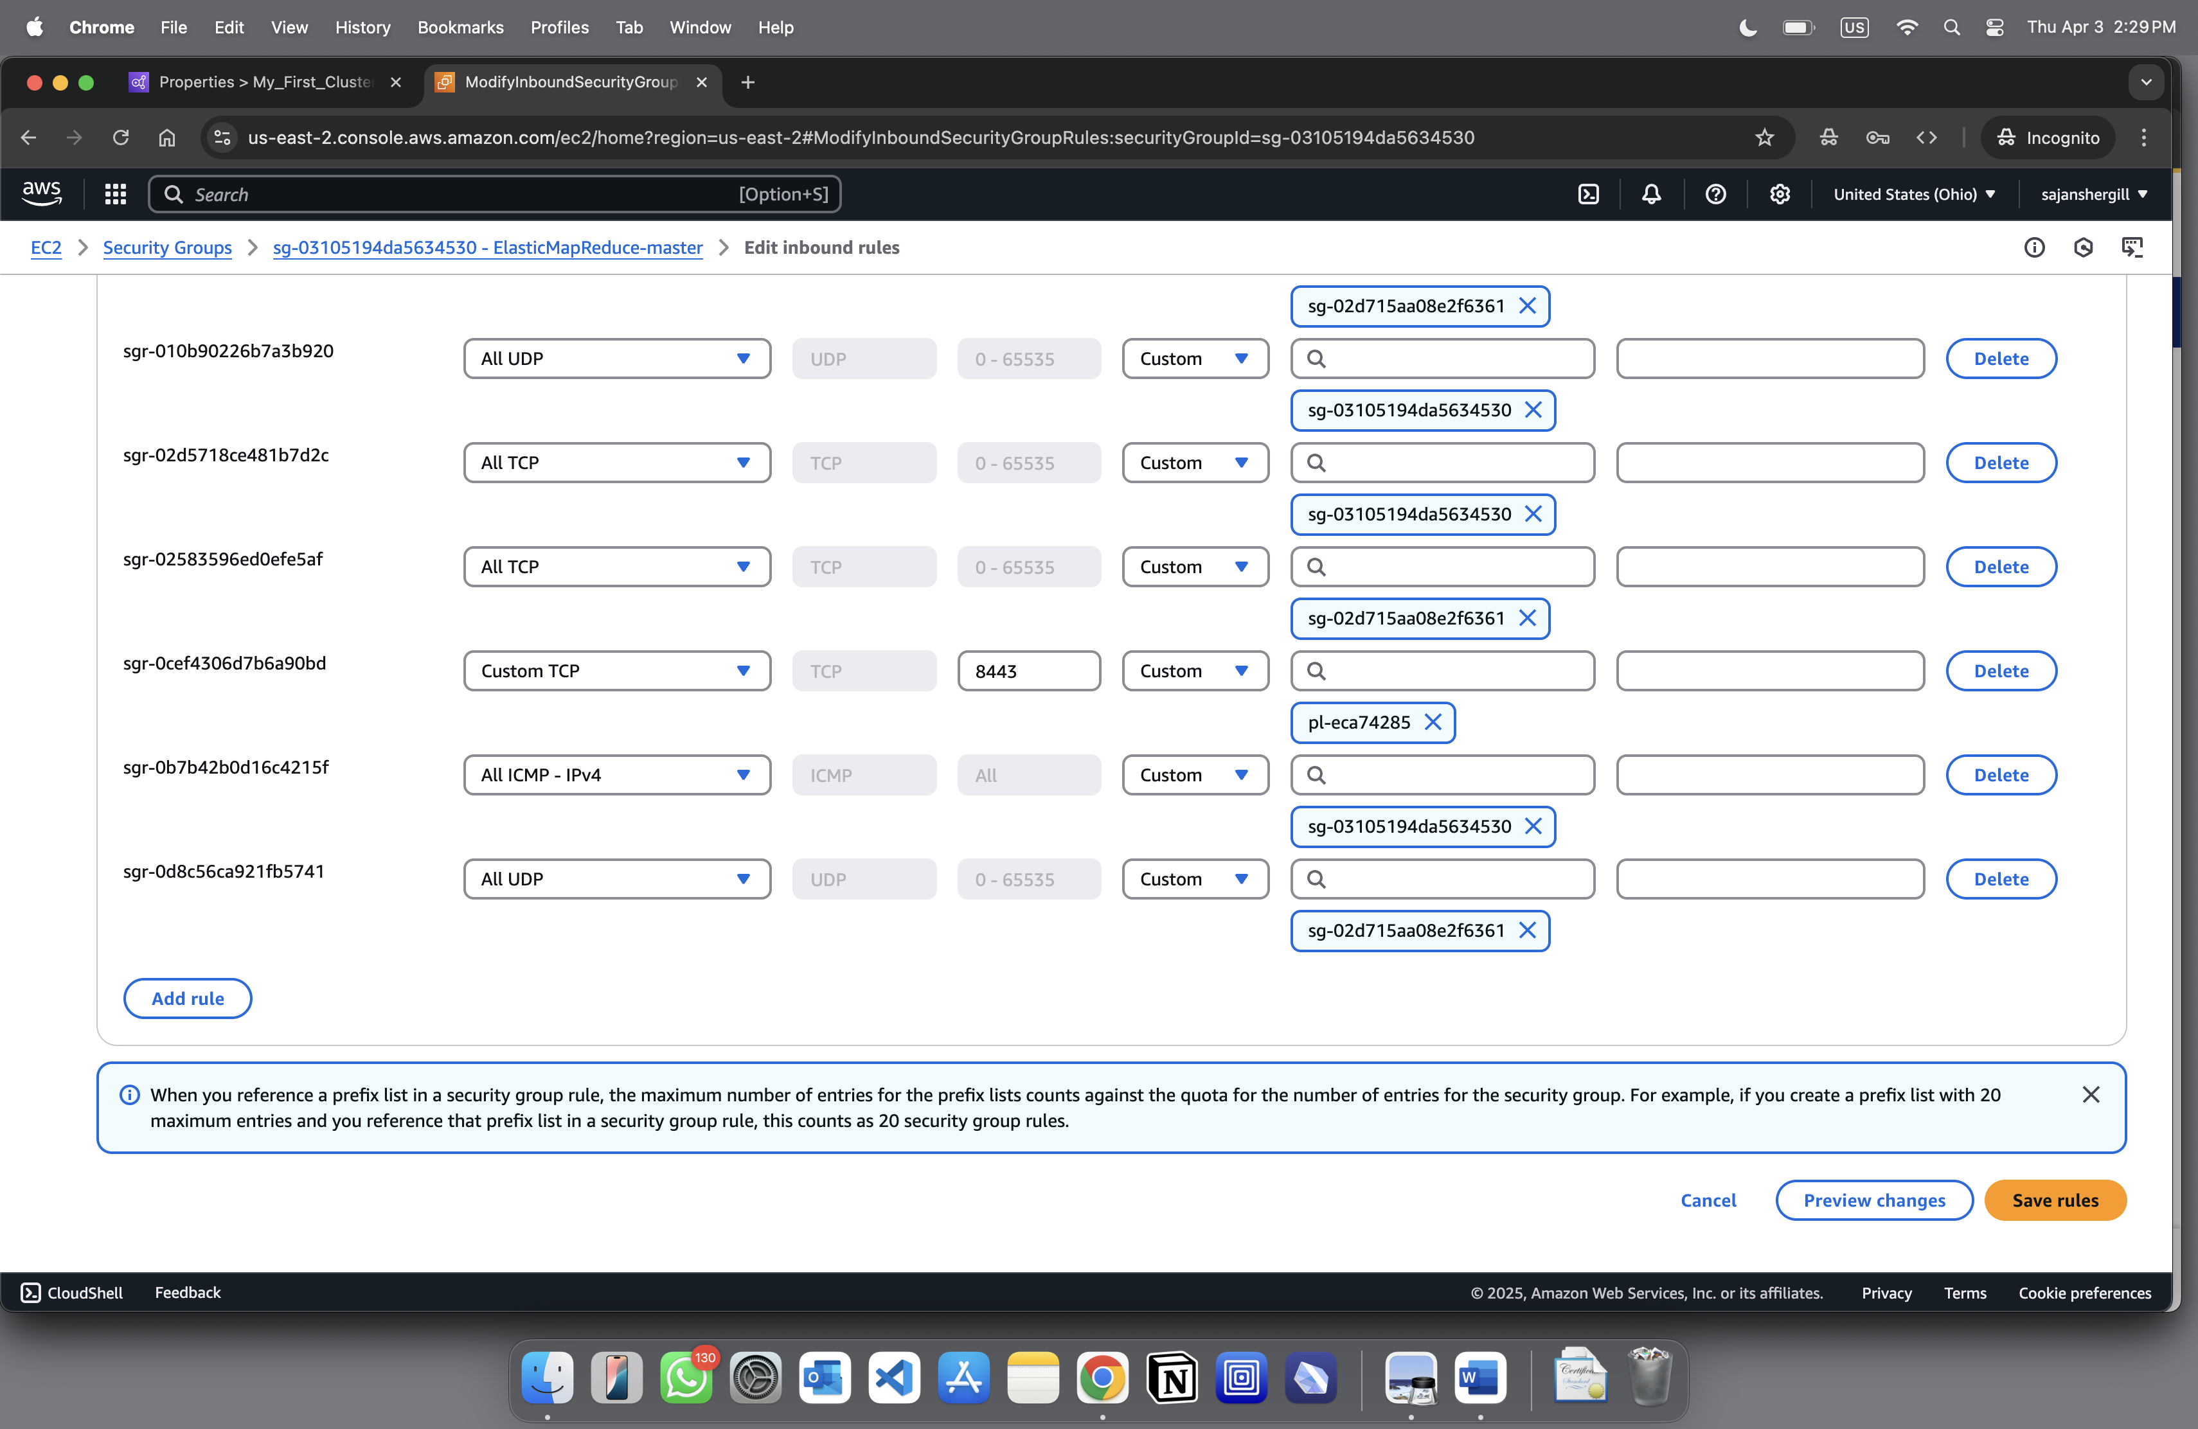
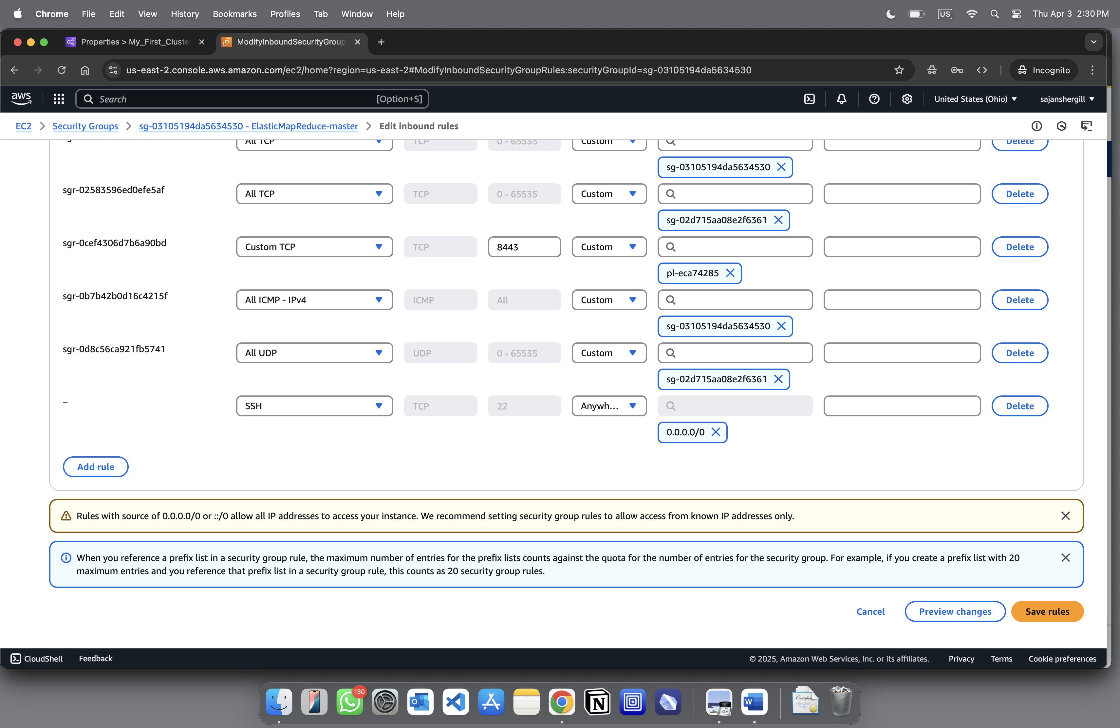
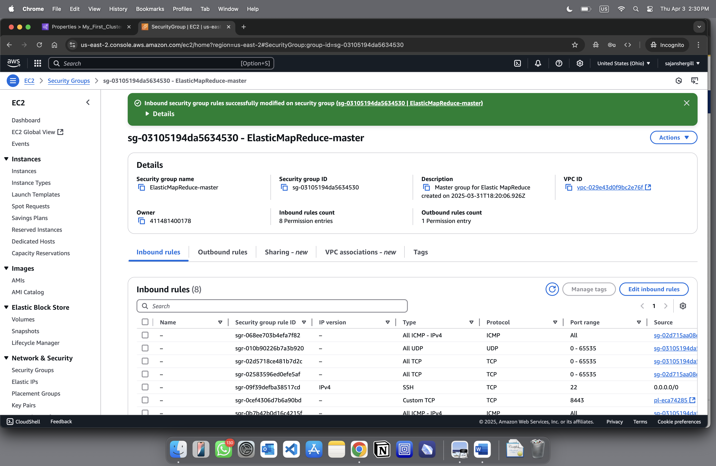
Click on “Save rules”

Connection to the EMR master node
3. Now connect to the EMR master node via putty to perform Hive table creation and ingestion of data
a. Search “EMR”
-> Click on Clusters Click on “View Cluster Details” . You will be able to see “Summary Information”
b. Click on “Connect to Master Node using SSH” , there will be your own link.
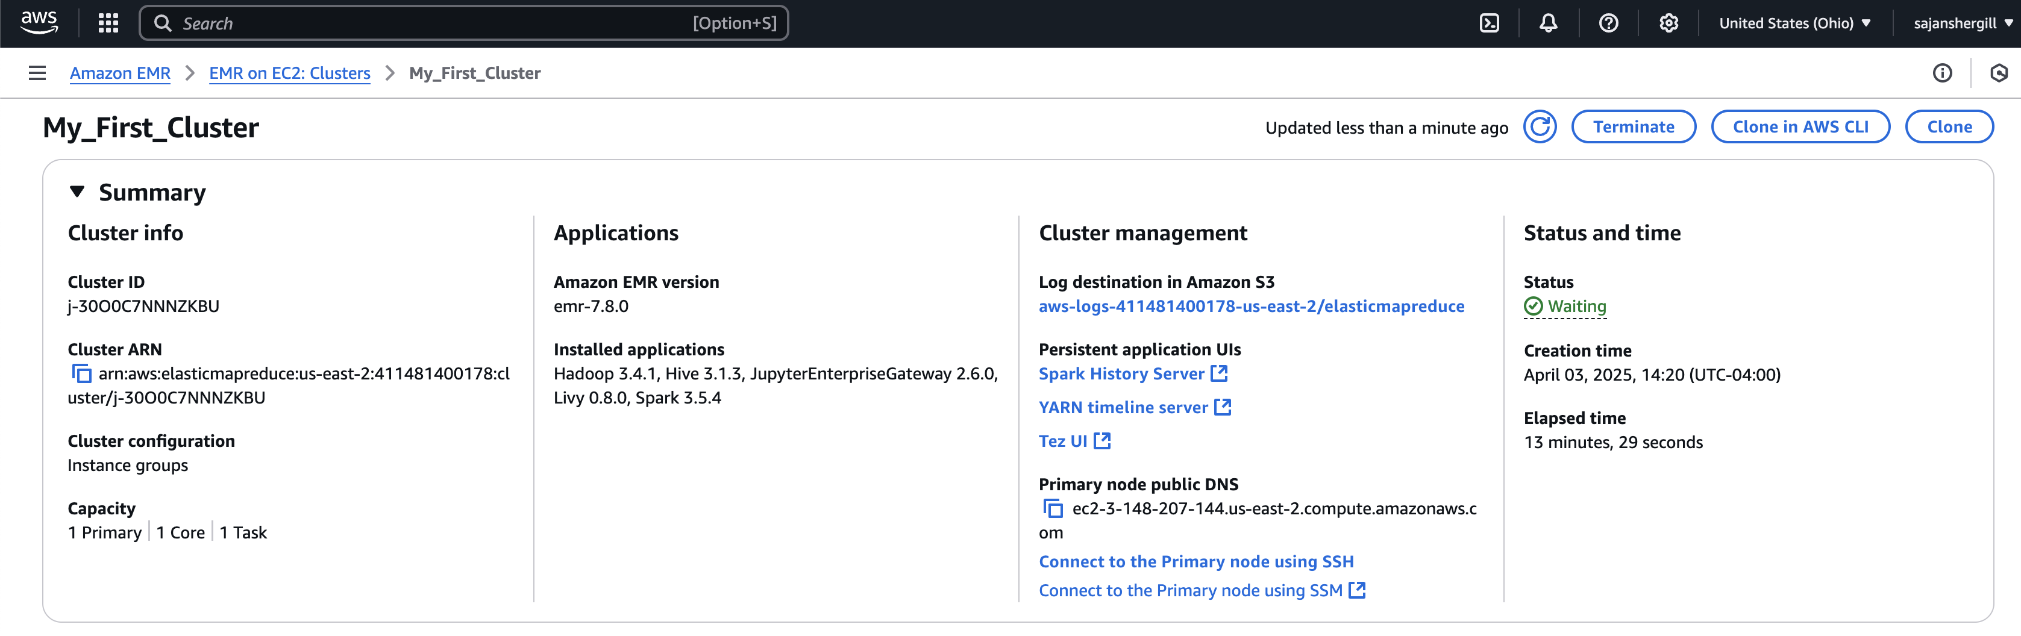
c. Open a terminal window. On Mac OS X, choose Applications > Utilities > Terminal.
d. To establish a connection to the primary node, enter the following command. Replace ~/CS673_AWS_Tutorial.pem with the location and filename of the private key file (.pem) that you used to launch the cluster.

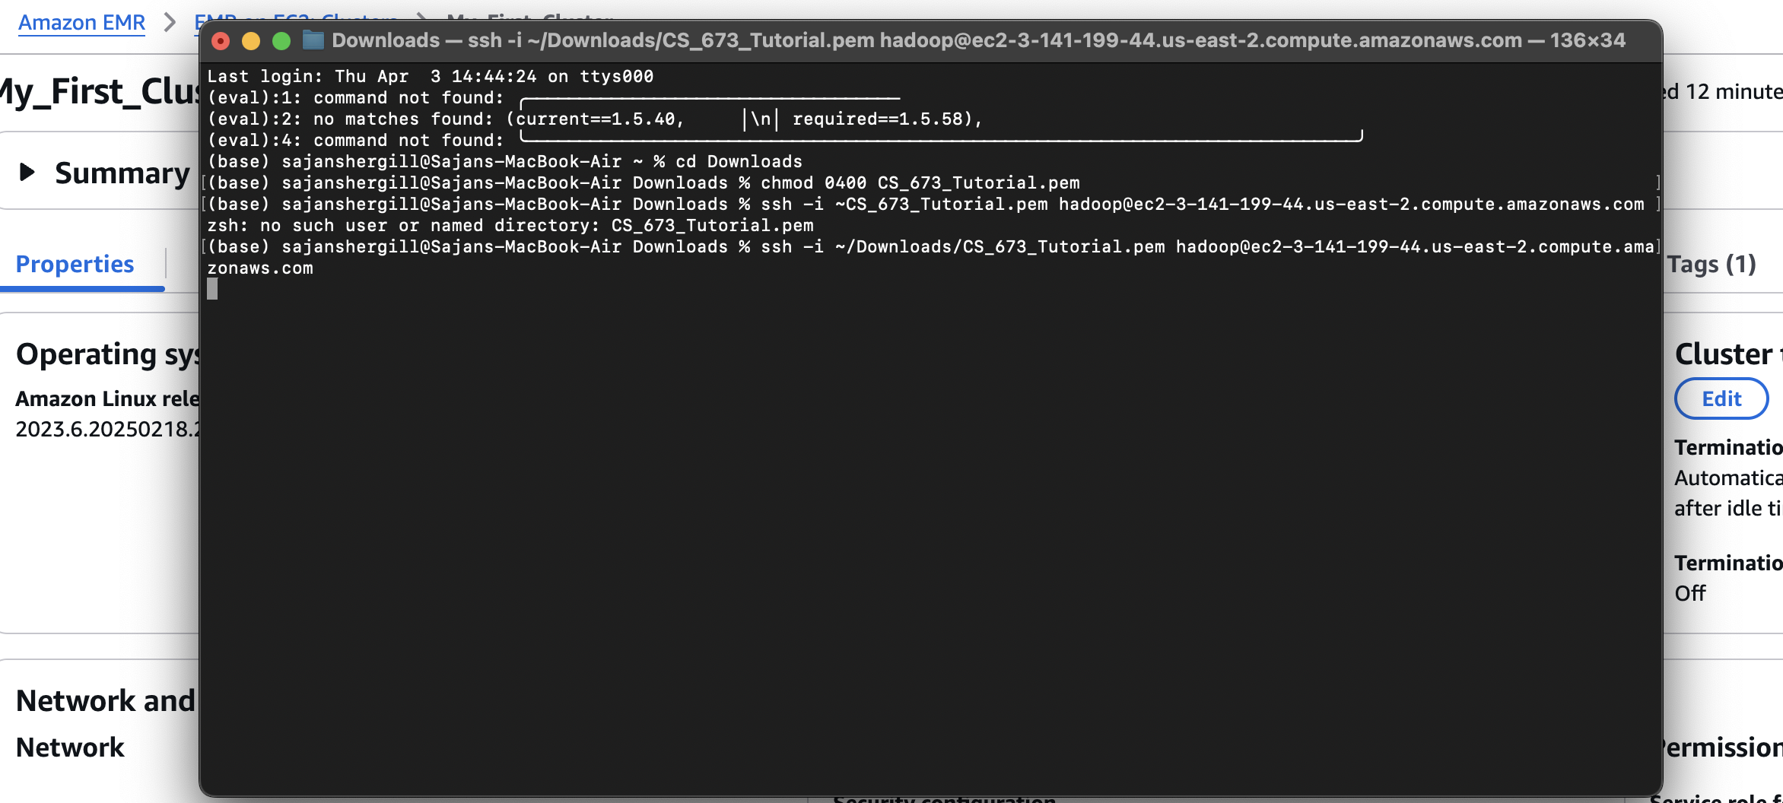
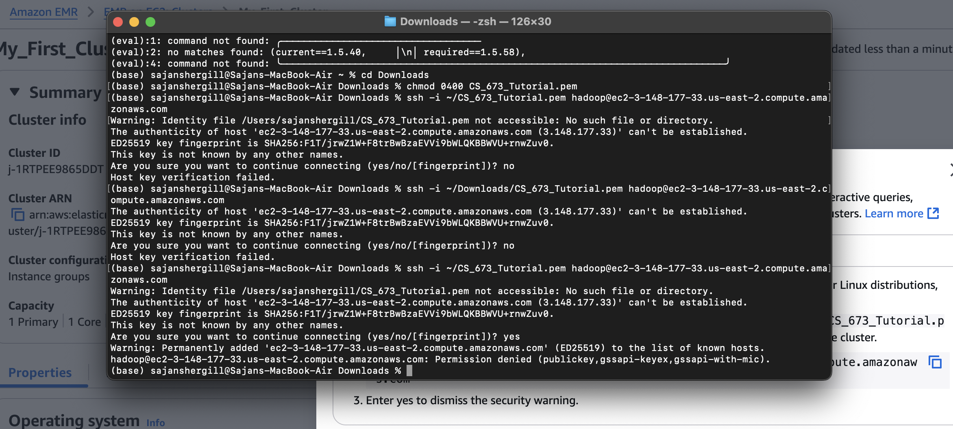
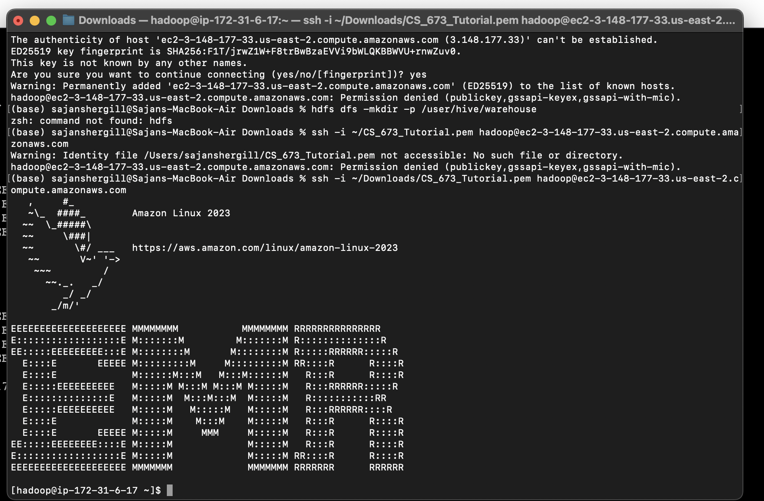

1. Create an hdfs directory and grant permission to it
a. Type the below commands on your master node:
hdfs dfs -mkdir -p /user/hive/warehouse
hdfs dfs -chmod g+w /user/hive/warehouse
2. Extract the features.zip file and unzip it
a. Run the below command: wget
https://docs.aws.amazon.com/amazondynamodb/latest/developerguide/samples/features.zip

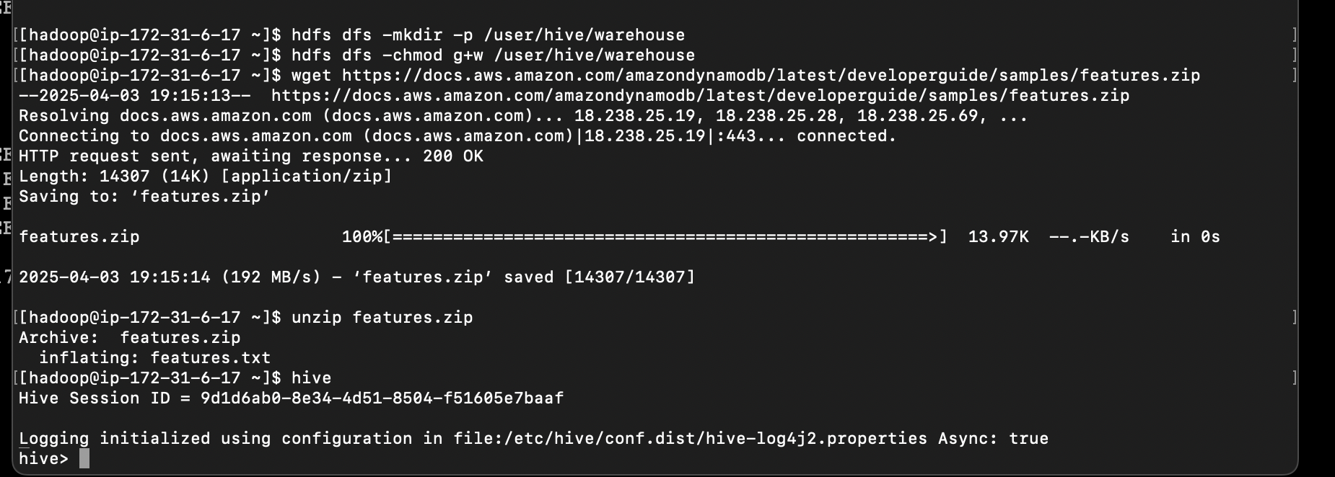

3. Create a Hive Table and ingest data into it:
a. Type “Hive” and hit enter
b. Create a table named “hive_features” using the below DDL:
CREATE TABLE hive_features (feature_id BIGINT,feature_name STRING ,feature_class
STRING,state_alpha STRING, prim_lat_dec DOUBLE, prim_long_dec DOUBLE ,elev_in_ft BIGINT)
ROW FORMAT DELIMITED FIELDS TERMINATED BY '|' LINES TERMINATED BY '\n';
c. Load the “features.txt” data within this table
LOAD DATA LOCAL INPATH '
./features.txt' OVERWRITE INTO TABLE hive_features;
e. Run the below query to display a list of states and number of geographic features in each of these
states:
SELECT state_alpha, COUNT(*) FROM hive_features GROUP BY state_alpha;

